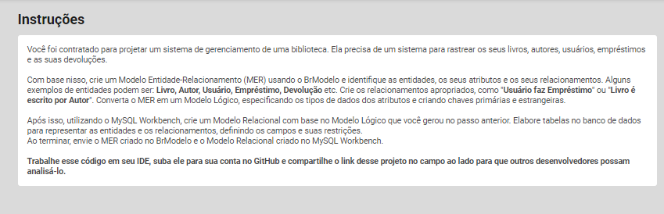

**MER – BrModel:**

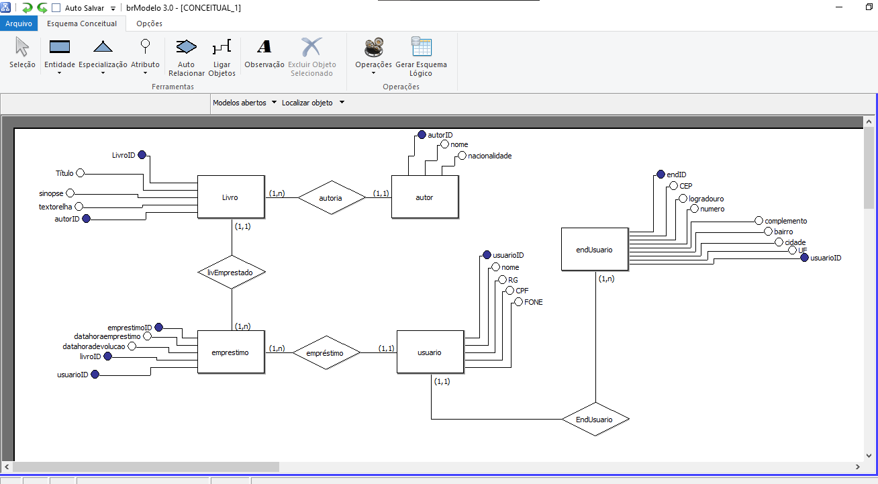

**Modelo Relacional – SQL Workbench:**